ASSIGNMENT 4
Ultrasonic sensor simulation in Wokwi

Student Name | BERLIN K
Student Roll Number | 961619106005

Question-1:
Write a code and connections in wokwi for the ultrasonic sensor. Whenever the distance is less than 100cms send an “Alert” to IBM cloud and display in the device recent events.

Code:

#include <WiFi.h> #include <PubSubClient.h>
void callback(char* subscribetopic, byte* payload, unsigned int payloadLength);
//-------credentials of IBM Accounts------
#define ORG "kotoq5"//IBM ORGANITION ID
#define DEVICE_TYPE "ESP32"//Device type mentioned in ibm watson IOT Platform #define DEVICE_ID "12345"//Device ID mentioned in ibm watson IOT Platform #define TOKEN "12345678" //Token
String data3;
char server[] = ORG ".messaging.internetofthings.ibmcloud.com"; char publishTopic[] = "iot-2/evt/Data/fmt/json";
char subscribetopic[] = "iot-2/cmd/test/fmt/String"; char authMethod[] = "use-token-auth";

char token[] = TOKEN;
char clientId[] = "d:" ORG ":" DEVICE_TYPE ":" DEVICE_ID;
WiFiClient wifiClient;
PubSubClient client(server, 1883, callback ,wifiClient); const int trigPin = 5;
const int echoPin = 18; #define SOUND_SPEED 0.034 long duration;
float distance; void setup() {
Serial.begin(115200); pinMode(trigPin, OUTPUT); pinMode(echoPin, INPUT); wificonnect(); mqttconnect();
}
void loop()
{
digitalWrite(trigPin, LOW); delayMicroseconds(2); digitalWrite(trigPin, HIGH); delayMicroseconds(10); digitalWrite(trigPin, LOW); duration = pulseIn(echoPin, HIGH);
distance = duration * SOUND_SPEED/2; Serial.print("Distance (cm): "); Serial.println(distance); if(distance<100)
{
Serial.println("ALERT!!"); delay(1000);

PublishData(distance); delay(1000);
if (!client.loop()) { mqttconnect();
}
}
delay(1000);
}
void PublishData(float dist) { mqttconnect();
String payload = "{\"Distance\":"; payload += dist;
payload += ",\"ALERT!!\":""\"Distance less than 100cms\""; payload += "}";
Serial.print("Sending payload: ");
Serial.println(payload);

if (client.publish(publishTopic, (char*) payload.c_str())) {
Serial.println("Publish ok");
} else {
Serial.println("Publish failed");
}
}
void mqttconnect() {
if (!client.connected()) { Serial.print("Reconnecting client to "); Serial.println(server);
while (!!!client.connect(clientId, authMethod, token)) {
Serial.print("."); delay(500);
}

initManagedDevice();
Serial.println();
}
}
void wificonnect()
{
Serial.println(); Serial.print("Connecting to "); WiFi.begin("Wokwi-GUEST", "", 6); while (WiFi.status() != WL_CONNECTED) { delay(500);
Serial.print(".");
}
Serial.println(""); Serial.println("WiFi connected"); Serial.println("IP address: "); Serial.println(WiFi.localIP());
}
void initManagedDevice() {
if (client.subscribe(subscribetopic)) { Serial.println((subscribetopic)); Serial.println("subscribe to cmd OK");
} else {
Serial.println("subscribe to cmd FAILED");
}
}
void callback(char* subscribetopic, byte* payload, unsigned int payloadLength)
{
Serial.print("callback invoked for topic: ");
Serial.println(subscribetopic);
for (int i = 0; i < payloadLength; i++) {

//Serial.print((char)payload[i]); data3 += (char)payload[i];
}
Serial.println("data: "+ data3); data3="";
}

Diagram.json:

{
"version": 1, "author": "Nitish Kumar",
"editor": "wokwi", "parts": [
{ "type": "wokwi-esp32-devkit-v1", "id": "esp", "top": -4.67, "left": -114.67, "attrs": {} },
{ "type": "wokwi-hc-sr04", "id": "ultrasonic1", "top": 15.96, "left": 89.17, "attrs": {} }
],
"connections": [
[ "esp:TX0", "$serialMonitor:RX", "", [] ],
[ "esp:RX0", "$serialMonitor:TX", "", [] ], [
"esp:VIN", "ultrasonic1:VCC", "red",
[ "h-37.16", "v-178.79", "h200", "v173.33", "h100.67" ]
],
[ "esp:GND.1", "ultrasonic1:GND", "black", [ "h39.87", "v44.04", "h170" ] ],
[ "esp:D5", "ultrasonic1:TRIG", "green", [ "h54.54", "v85.07", "h130.67" ] ],
[ "esp:D18", "ultrasonic1:ECHO", "green", [ "h77.87", "v80.01", "h110" ] ]

]
}

Circuit Diagram:
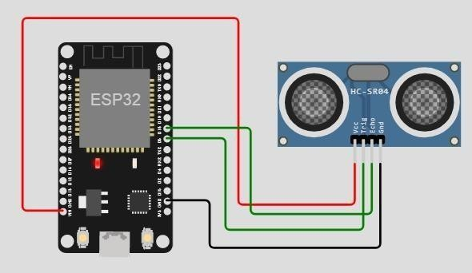
Output:
Wokwi output:
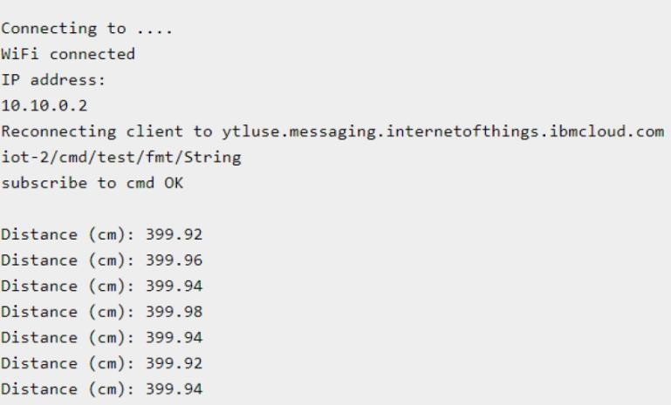

IBM cloud output:
